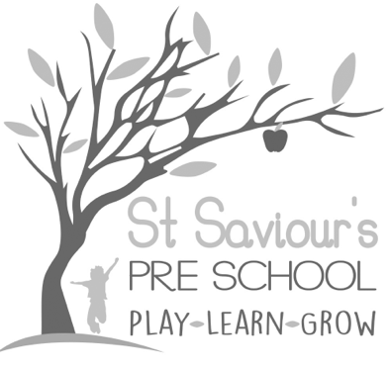
6.7 DATA PROTECTION

Written by: Claire Toms and Tina Alder Date: 1.09.22. – reviewed 08.10.24.

Policy Statement
St Saviour’s Preschool and Nursery collects, processes, and stores personal information about staff, students, parents or carers, and other individuals who interact with the setting. This information is gathered to support education, safeguarding, and other statutory functions. Additionally, there may be a legal requirement to collect and use certain information to ensure compliance with statutory obligations.
We are registered as Data Controllers with the Information Commissioner’s Office (ICO), detailing the categories of information held and its purposes. These details are publicly available on the ICO website.
All staff, volunteers, and relevant stakeholders must comply with this policy to ensure personal information is handled lawfully, securely, and transparently, in line with the Data Protection Act 2018, GDPR, and the new EYFS 2025 Safeguarding and Welfare Requirements.

Purpose
This policy ensures that:
- Personal information is processed lawfully, fairly, and transparently.
- Data is collected for specified, legitimate purposes only.
- Personal information is adequate, relevant, and not excessive.
- Records are accurate, kept up to date, and retained only for as long as necessary.
- Individuals’ rights under the Data Protection Act 2018 are respected and upheld.
- Data is kept secure through appropriate technical and organisational measures.
- Personal information is not transferred outside the UK or EEA without adequate protection.

Definition of Personal Information
Personal information (data) is defined as any data that relates to a living individual who can be identified from that data, or from other information held by the setting.

Principles
All processing of personal data must comply with the eight enforceable principles of the Data Protection Act 2018:
- Processed fairly and lawfully.
- Obtained for specified, lawful purposes only.
- Adequate, relevant, and not excessive.
- Accurate and, where necessary, kept up to date.
- Not kept longer than necessary.
- Processed in accordance with the rights of the data subject.
- Kept secure.
- Not transferred outside the European Economic Area unless adequate protection is ensured.

Authorised Disclosures
St Saviour’s Preschool and Nursery will only disclose personal data with the individual’s consent, except in circumstances required by law, safeguarding, or the setting’s statutory obligations.
These limited circumstances include:
- Child/pupil data shared with educational authorities, health professionals, and other relevant agencies.
- Child/pupil data shared with parents or carers regarding progress, attendance, welfare, and achievements.
- Staff data shared with payroll, pensions, and statutory authorities.
Only authorised staff may make external disclosures. Internal access is limited to professionals working directly with the child or individual and who have a legitimate need to know.

Physical & Digital Security
- Records are stored in locked cabinets, and digital data is password-protected.
- Visitor access is controlled; all visitors must sign in/out and be accompanied where appropriate.
- Staff must report any suspected breaches immediately to the manager.

Retention and Disposal of Records
- Paper records are shredded when no longer required.
- Electronic records are permanently deleted from all devices.
- Staff are reminded that unauthorised use or disclosure may result in legal liability and disciplinary action, including potential dismissal.

Supporting Documents
- Fair Processing Notice (Appendix 1)
- GDPR and Data Protection Act 2018 guidance from the ICO https://ico.org.uk

Appendix 1 – Fair Processing Notice
St Saviour’s Preschool and Nursery processes children’s information to:
- Support child development and progress monitoring.
- Provide appropriate pastoral care and welfare.
- Assess overall effectiveness of the setting.
Information may include:
- Contact details, attendance, characteristics (e.g., ethnic group, special educational needs), and medical information.
Data may be shared with:
- Local Authorities (LAs) for statutory functions and support.
- Department for Education (DfE) / Secretary of State for education purposes.
- Ofsted and other regulatory bodies for inspection and monitoring.
- Health professionals for safeguarding or medical care.
Children and parents/carers have the right to:
- Request access to personal data held by the setting.
- Request correction of inaccuracies.
- Withdraw consent where applicable.
To access personal data:
- Contact St Saviour’s Preschool and Nursery, 15 Gurney Court Rd, St Albans, Herts, AL1 4QU
- Contact Hertfordshire County Council, Data Protection Team, County Hall, Pegs Lane, Hertford, SG13 8DQ
Proof of identity may be requested to protect personal data.

